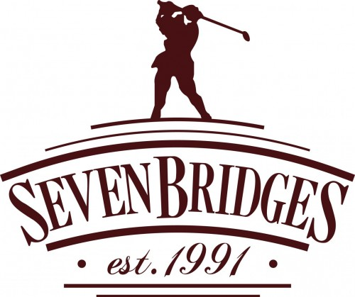
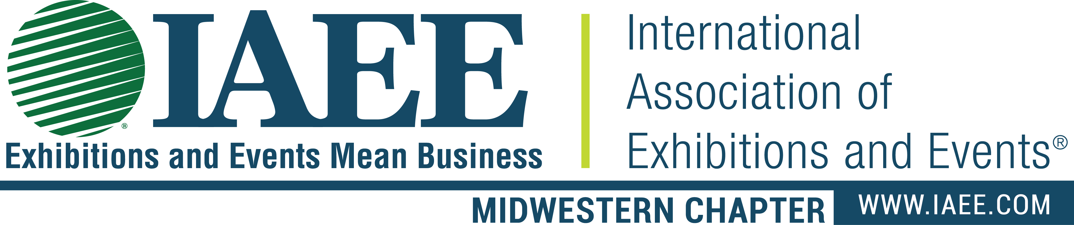

We’re changing it up again…Are you ready to Par Tee?

The IAEE Midwestern Chapter takes the 32nd Annual Golf Outing back to Seven Bridges Golf Club in
beautiful Woodridge, IL for a day of celebrating with show organizers and industry colleagues. We will
be telling tall tales, eating, drinking, laughing and making long putts. This is the perfect occasion to visit
with old friends and make new ones – don’t miss it!

IAAE Midwestern Chapter enjoys participation from notable international, national and regional associations, along with prominent independent show organizers and management companies.
A rich and active group of planners with a varied portfolio of meetings, conventions and exhibitions dominate our membership.

A full menu of modestly priced Sponsorships are available to promote your company or
destination. Bring a guest or find a partner - Event Organizers can pair up with another
planner or be a hosted by a partner organization to receive an additional discount. Choose
your options wisely my friends, as engaging with the IAEE/MWC membership is a perfect compliment to the sales and marketing efforts of meeting and convention industry vendors
and suppliers.

Mark your calendars and register early for Wednesday, September 1, 2021.

Check-in and warm-up: 7:30 a.m. – 8:30 a.m.
Shot gun start with a grab and go breakfast: 8:30 a.m.
Lunch and prizes: 1:00 p.m. – 2:00 p.m.

Have questions about the outing? Want more information? Please contact us at info@IAEEMWC.com

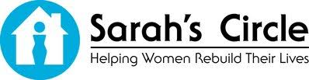
Help us support Sarah’s Circle

Donate gifts, prizes, weekend stays, meals, etc. to be raffled off at the Outing. We will make certain the revenue brought in by your raffle prize benefits our chapter charity, Sarah’s Circle (“mission of serving women who are homeless or in need of a safe place”).

~Participation Opportunities~

Hole Sponsorship - $1,100
- One (1) foursome with cart.
- Table at the hole for one company
representative to distribute corporate
gifts. One hole worker receives breakfast
and lunch.
Any additional hole workers will be charged
for the breakfast and lunch.
- Breakfast and lunch for all in the foursome.
- Use of the locker room facilities for both men
and women.
- Company logo sign at the hole and on all pre promotions.

Foursome – $700
- One (1) foursome with cart.
- Breakfast and lunch for all in the foursome.
- Use of the locker room facilities for both men
and women.

Golf Pair (Supplier and Planner only) - $325
- Two golfers with cart. Must be a supplier and a planner.
- Breakfast and lunch for both golfers.
- Use of the locker room facilities for both men and women.

Individual Golfer- $175
- Individual golf spaces are only guaranteed if a
foursome can be filled.
- Spaces are given on a first-come basis.
- Golfers will be notified once a foursome is
complete.

Lunch only - $45
- Not a golfer or can’t make it for the full day?
Join us at the lunch and prizes presentation.
Welcome Gift Sponsor – Sponsor’s choice
• Provide a welcome gift given to all golfers (Gift to include sponsor company logo &
IAEE logo).
- Company logo on all pre promotions

Hole Sponsor (Non golfing) - $500 each
- Opportunity to meet and greet golfers on a pre-assigned hole (two people)
- Opportunity to provide a contest and/or
give-away to the golfers
- Lunch for two people.
- Company logo on all pre promotions

Lunch Sponsorship- $750 Exclusive SOLD
• Complimentary registration for golfer’s
lunch for two.
- Company logo signs at the lunch pick-up.
- Company logo on all pre promotions

Breakfast Sponsorship- $500 Exclusive
• Company logo sign at the breakfast.
- Company logo on all pre promotions.

PARched Beverage Cart Sponsorship- $750 SOLD
- Complimentary registration for lunch
for one.
• Company logo signs on beverage cart.
• Company listing in golf outing program.
Bloody Mary Bar “Welcome” at registration - $500 exclusive
- Company logo sign at the registration.
- Sponsor is responsible for the cost of the beverage and condiments.
- Company logo on all pre promotions.

The Turn - snack and beverage sponsor - $500 exclusive
- Company logo sign at The Doc outdoor grill.
- Company logo on all pre promotions.

Cigar Sponsor - $500 exclusive
- Company logo sign at registration.
- Company logo on all pre promotions.

If you don’t see a sponsorship opportunity listed, let us know.

